**Automation Test**

Create a automation **project** to test the following application. [Mobile application](https://drive.google.com/drive/u/0/folders/1r820fJjw8ax9bRB-i4Rr8UHEa-AIveDs) or [Web Application](http://35.154.209.120/)

**About application:**

It’s a two screen application. First is the login screen and second is the listing screen.

**For the first screen:**

Write validation test cases by reading the input from an [excel sheet](https://drive.google.com/drive/u/0/folders/1r820fJjw8ax9bRB-i4Rr8UHEa-AIveDs) and testing for validation messages.

Validation messages on first screen are as follows:

1. **"Enter valid email id"**
2. **"Invalid password"**
3. **"Enter password"**

To get to second screen enter **any valid email id** and enter password as **P@ssw0rd.**

**For second screen:**

1. Write test cases to test scrolling and test if the last name is **You.**
2. On click of any of the name test if the toast message displays the correct name or not.

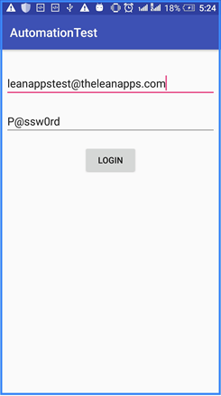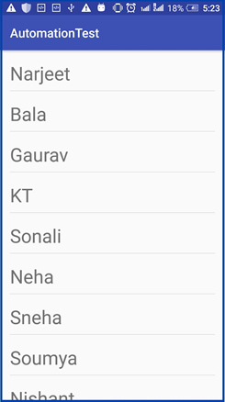

**Web Application**

